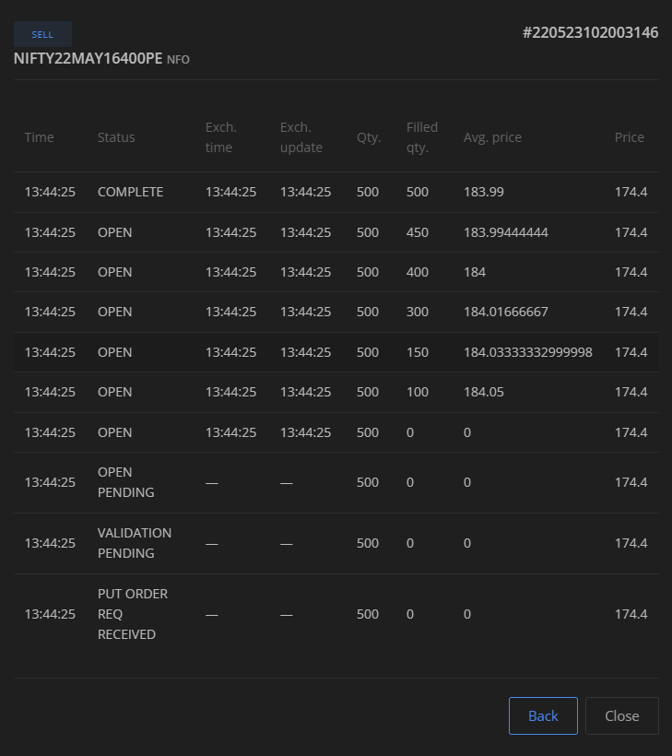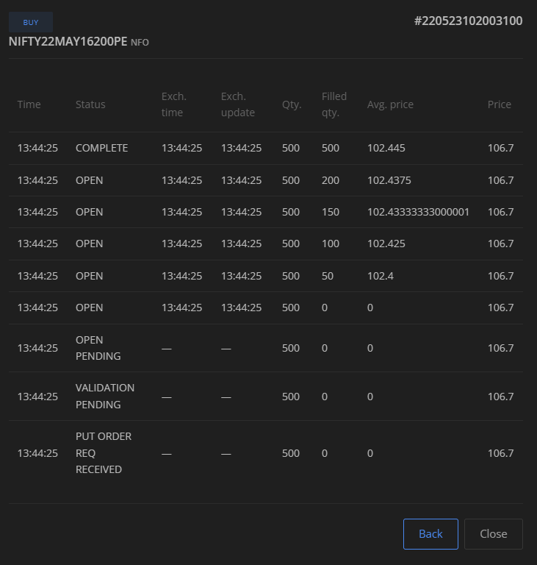



|  |  |  |  |  |  |  |  |  |  |  |  |  |  |  |  |  |  |  |  |  |  |  |  |  |  |  |  |  |
| --- | --- | --- | --- | --- | --- | --- | --- | --- | --- | --- | --- | --- | --- | --- | --- | --- | --- | --- | --- | --- | --- | --- | --- | --- | --- | --- | --- | --- |
| TradingSymbol | Exchange | ProdType | Quantity | InstrumentToken | OvernightQuantity | Multiplier | AveragePrice | ClosePrice | LastPrice | Value | PNL | M2M | Unrealised | Realised | BuyQuantity | BuyPrice | BuyValue | BuyM2M | SellQuantity | SellPrice | SellValue | SellM2M | DayBuyQuantity | DayBuyPrice | DayBuyValue | DaySellQuantity | DaySellPrice | DaySellValue |
| -------------------------------------------------- | --------------- | --------------- | ----------- | -------------------------------------------------- | ----------------- | ----------- | --------------------- | --------------------- | --------------------- | ------------- |  |  |  |  |  |  |  |  |  |  |  |  |  |  |  |  |  |  |
| NIFTY22MAY16300PE | NFO | NRML | 0 | 14223106 | 0 | 1 | 0 | 0 | 113.3 | 12750 | 12750 | 12750 | 12750 | 0 | 500 | 123.47 | 61735 | 61735 | 500 | 148.97 | 74485 | 74485 | 500 | 123.47 | 61735 | 500 | 148.97 | 74485 |
| NIFTY22MAY16350CE | NFO | NRML | 0 | 14223362 | 0 | 1 | 0 | 0 | 179.8 | -7947.5 | -7947.5 | -7947.5 | -7947.5 | 0 | 500 | 163.19 | 81595 | 81595 | 500 | 147.295 | 73647.5 | 73647.5 | 500 | 163.19 | 81595 | 500 | 147.295 | 73647.5 |
| NIFTY22MAY15900PE | NFO | NRML | 0 | 14210562 | 0 | 1 | 0 | 0 | 33.3 | 2132.5 | 2132.5 | 2132.5 | 2132.5 | 0 | 1500 | 69.8717 | 104807.5 | 104807.5 | 1500 | 71.2933 | 106940 | 106940 | 1500 | 69.8717 | 104807.5 | 1500 | 71.2933 | 106940 |
| NIFTY22MAY16100PE | NFO | NRML | 0 | 14216450 | 0 | 1 | 0 | 0 | 60.5 | -2765 | -2765 | -2765 | -2765 | 0 | 1600 | 86.8531 | 138965 | 138965 | 1600 | 85.125 | 136200 | 136200 | 1600 | 86.8531 | 138965 | 1600 | 85.125 | 136200 |
| NIFTY22MAY16250CE | NFO | NRML | 0 | 14222082 | 0 | 1 | 0 | 0 | 244.85 | 13527.5 | 13527.5 | 13527.5 | 13527.5 | 0 | 1100 | 173.4068 | 190747.5 | 190747.5 | 1100 | 185.7045 | 204275 | 204275 | 1100 | 173.4068 | 190747.5 | 1100 | 185.7045 | 204275 |
| NIFTY22MAY16250PE | NFO | NRML | 0 | 14222594 | 0 | 1 | 0 | 0 | 96.4 | -18562.5 | -18562.5 | -18562.5 | -18562.5 | 0 | 2100 | 181.7155 | 381602.5 | 381602.5 | 2100 | 172.8762 | 363040 | 363040 | 2100 | 181.7155 | 381602.5 | 2100 | 172.8762 | 363040 |
| NIFTY22MAY16300CE | NFO | NRML | 0 | 14222850 | 0 | 1 | 0 | 0 | 210.75 | -6580 | -6580 | -6580 | -6580 | 0 | 500 | 184.25 | 92125 | 92125 | 500 | 171.09 | 85545 | 85545 | 500 | 184.25 | 92125 | 500 | 171.09 | 85545 |
| NIFTY22MAY16400CE | NFO | NRML | 0 | 14223874 | 0 | 1 | 0 | 0 | 152.3 | 4360 | 4360 | 4360 | 4360 | 0 | 500 | 122.9 | 61450 | 61450 | 500 | 131.62 | 65810 | 65810 | 500 | 122.9 | 61450 | 500 | 131.62 | 65810 |
| NIFTY22MAY16500CE | NFO | NRML | 0 | 14227458 | 0 | 1 | 0 | 0 | 103.7 | -7337.5 | -7337.5 | -7337.5 | -7337.5 | 0 | 3500 | 73.4643 | 257125 | 257125 | 3500 | 71.3679 | 249787.5 | 249787.5 | 3500 | 73.4643 | 257125 | 3500 | 71.3679 | 249787.5 |
| NIFTY22MAY16600CE | NFO | NRML | 0 | 14230530 | 0 | 1 | 0 | 0 | 65.65 | -2682.5 | -2682.5 | -2682.5 | -2682.5 | 0 | 5500 | 55.1536 | 303345 | 303345 | 5500 | 54.6659 | 300662.5 | 300662.5 | 5500 | 55.1536 | 303345 | 5500 | 54.6659 | 300662.5 |
| NIFTY22MAY16700CE | NFO | NRML | 0 | 14231554 | 0 | 1 | 0 | 0 | 38.95 | 1635 | 1635 | 1635 | 1635 | 0 | 1000 | 26.315 | 26315 | 26315 | 1000 | 27.95 | 27950 | 27950 | 1000 | 26.315 | 26315 | 1000 | 27.95 | 27950 |
| IRFC-N3 | NSE | CNC | 100 | 7506177 | 0 | 1 | 1054.16 | 0 | 1054.1 | -105416 | -6 | -6 | -6 | 0 | 100 | 1054.16 | 105416 | 105416 | 0 | 0 | 0 | 0 | 100 | 1054.16 | 105416 | 0 | 0 | 0 |
| NIFTY22MAY16000PE | NFO | NRML | 0 | 14213890 | 0 | 1 | 0 | 0 | 45 | 2940 | 2940 | 2940 | 2940 | 0 | 1000 | 46.1 | 46100 | 46100 | 1000 | 49.04 | 49040 | 49040 | 1000 | 46.1 | 46100 | 1000 | 49.04 | 49040 |
| NIFTY22MAY16200PE | NFO | NRML | -500 | 14221826 | 0 | 1 | 83.4 | 0 | 82.9 | 41700 | 250 | 250 | 250 | 0 | 0 | 0 | 0 | 0 | 500 | 83.4 | 41700 | 41700 | 0 | 0 | 0 | 500 | 83.4 | 41700 |
| NIFTY22MAY16400PE | NFO | NRML | 500 | 14226690 | 0 | 1 | 154.525 | 0 | 154.25 | -77262.5 | -137.5 | -137.5 | -137.5 | 0 | 500 | 154.525 | 77262.5 | 77262.5 | 0 | 0 | 0 | 0 | 500 | 154.525 | 77262.5 | 0 | 0 | 0 |